Christian Aid Week 2025

A guide to promoting Christian Aid Week in your community

Contents
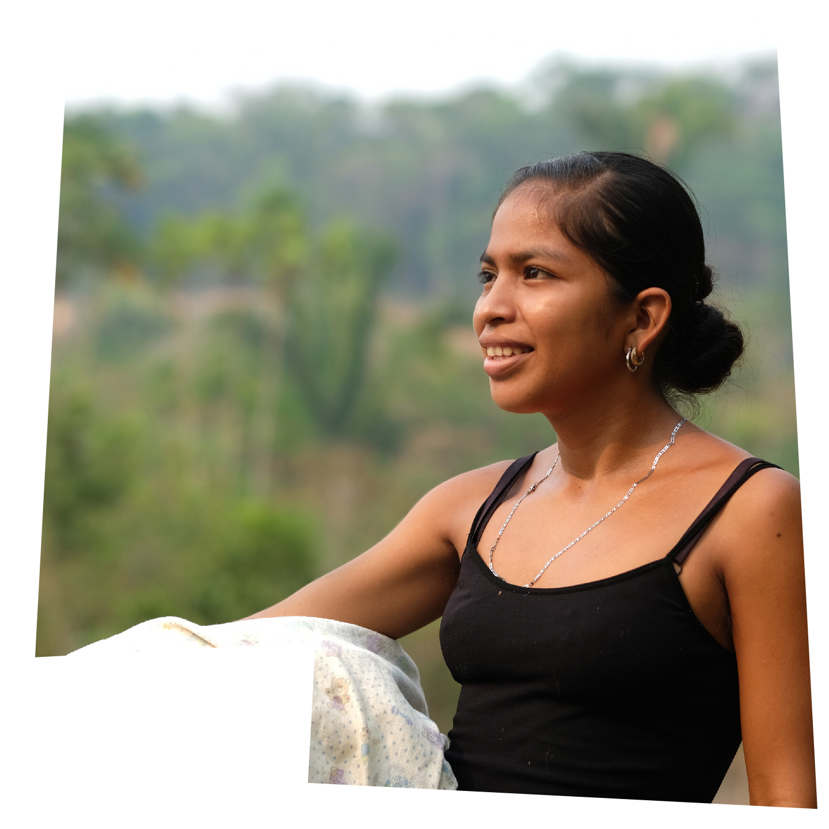

- Thanks for your support
- Campaign article (around 1,000 words)
- Campaign article (around 700 words)
- Campaign article (around 300 words)
- 70k in May
- Christian Aid logos
- Images
Amelia, taking her washing down to the river
- A guide to using our template press releases
- Template press release for general fundraising
- Template press release for 70k in May.

Thanks for your support

Thank you so much for promoting Christian Aid Week (11-17 May). We hope the stories and images in this pack will help you tell people about our work and encourage them to show their support too.

We each have 7 days to make a difference and there are plenty of ways people can get involved.

In this pack, you’ll find Christian Aid logos for you to use, and an article about the campaign that’s the perfect length for websites and magazines. Plus, there are two shorter versions of the piece for newsletters and leaflets, along with images to accompany all three articles. We’ve also shared some examples of what the donations we all raise this Christian Aid Week could go on to fund. You’ll also learn about our 70k in May fundraising challenge, which is a great opportunity to achieve some personal fitness goals while raising money.

If you’re using social media, don’t forget to tag us, so we can share your posts too!

- Facebook: @christianaidireland
- Instagram: @christianaidirl

We have plenty of resources available for you to use at caweek.ie/Resources and if you need extra support, please get in touch at belfast@christian-aid.org or dublin@christian-aid.org

Without your support, we couldn’t do all that we do – so thank you very much.

Campaign article (around 1,000 words)

Dying crops means food stops

Uncertainty looms over Indigenous farming communities in the Alta Verapaz region of Guatemala, Central America.

In this forested area of mountains and rivers, the livelihoods, traditions and very survival of farmers and their families are threatened by deadly droughts, savage storms and monster monoculture plantations.

That includes Amelia, a resourceful and determined 24-year-old farmer who lives with her husband and their two children, 8-year-old Lázaro and 4-year-old Yakelin, on ancient and beautiful land that’s been in Amelia’s family for generations. ‘I have always been fascinated by planting and have loved it since I was very young,’ she says. The family belong to the Indigenous Q’eqchi’ community.

Amelia’s farm, first and foremost, feeds her young children. She tries to grow a range of crops and root vegetables that will provide them with a balanced diet, such as bananas, peppers and cassava. This way, Amelia can protect them from malnutrition.

But the climate crisis is ravaging farms like Amelia’s, causing both the dry and rainy seasons that would once arrive with predictability to intensify and shift erratically. Recent harvests have failed, and fruit and vegetables have become unobtainable locally. The family’s diet now largely consists of rice and tortillas.

‘My first priority is to feed my family,’ says Amelia. ‘I worry about what my children will eat.’

Water is life

The river is central to Amelia’s life and Mayan culture. When Amelia was a child, the river that runs through her farm was bigger and deeper than it is now. There were crabs, shrimp, big fish, and enough water for her to learn to swim.

Now, as Amelia’s own children splash around in the cool waters to escape the blistering temperatures that relentless heatwaves bring, the water is at ankle height.

‘The river is getting lower and most of the water sources are just dust,’ Amelia explains. It’s a heartbreaking injustice, when no more than a mile away, industrial plantations are taking the last of the region’s natural resources to feed the world’s richest countries.

As the river runs dry and water becomes scarce, the vital crops that Amelia depends on wither and die before her eyes. Amelia’s ability to protect Lázaro and Yakelin is slipping away. Because dying crops means food stops.

A cruel injustice

Farming families in the Alta Verapaz region are exceptionally vulnerable to hunger when their crops fail.

Guatemala is a hunger hotspot. At 46.5%, the country has one of the highest global rates of stunting in children. In some areas, this rises to 90%. Stunting permanently affects both physical and mental development. Meanwhile, more than half of people in Guatemala work in agriculture. In the Alta Verapaz region, dependency on agriculture is the highest in the country. Heartbreakingly, malnutrition in children under five is also at the highest here.

Guatemala is among the 10 countries in the world rated most vulnerable to disasters and climate emergencies. The cruel truth is that Indigenous communities like Amelia’s have done the least to cause the climate crisis, yet they endure its impact the most.

As their farms are devastated, the search for solutions becomes critical. ‘With high heat, there is little we can do but adapt,’ says Amelia.

The unstoppable power of hope

Despite all this, Amelia’s hopeful that she can combat extreme weather by changing the way she farms – with the support of specialist training from Christian Aid’s partner, Congcoop.

Christian Aid has been working in Guatemala with Congcoop since 2011. In 2020, when hurricanes Eta and Iota hit the Alta Verapaz region, forcing more than 198,000 people out of their homes and into shelters, Congcoop offered vital humanitarian aid.

Today, Congcoop are supporting communities to return to Indigenous farming practices and adopt agroecological approaches that conserve their land, culture and livelihood.

Agroecology, put simply, is farming in a sustainable way that works with, not against, nature. An agroecological approach adapts to suit the specific environmental conditions of an area. It encourages the protection of the forest and wider environment, as well as the use of native seeds such as corn, cacao, maize, beans and medicinal herbs.
When Amelia discovered Congcoop’s work, she quickly put herself forward as a community representative who would attend the specialist agricultural training on offer.

By joining Congcoop, Amelia’s gaining the skills and knowledge to cultivate native seeds that are better suited to the changing climate. She’s planning planting schedules that will deliver multiple harvests throughout the year, making her own organic fertiliser, and constructing rainwater collection systems. By changing the way she farms, Amelia’s pushing back against the climate crisis. Congcoop also supports people with selling produce locally and campaigning for their rights.

Amelia says: ‘The training has been very helpful to preserve and conserve native seeds.’

Amelia is recognised as a leader in her community. Whatever she learns, she shares – confidently training other women to adapt their farming practices too.

Looking to the near future, Amelia says: ‘For the future, I don’t know what to expect, it could be worse, it could be better. The only one who can tell, is God.’

But whatever the future may hold, Amelia remains resilient. As Programme Officer, Gerardo C. Tobar, says: ‘Amelia’s story is one of resistance, and it’s just beginning.’

The unstoppable power of hope compels Christian Aid and its amazing supporters to stand up for communities in crisis and support people living in poverty.
The organisation, now in its 80th year, and its supporters are joining together once again during Christian Aid Week (11-17 May) to fundraise in all kinds of ways – from coffee mornings and craft stalls to hiking and biking for the 70k in May challenge.

With 7 days to make a difference, every gift, act and prayer counts.

Will you demonstrate the unstoppable power of hope and help fund vital tools and training, so farmers like Amelia can push back against the climate crisis and beat hunger?

- £6/ €7 could pay for the seed trays that kickstart a plant nursery at someone’s home.
- £10/ €11 could pay for the pruning scissors that mean a farmer can care for their cacao trees.
- £20/ €21 could buy two pounds of climate resilient seeds that diversify a family’s crop.

Find out more about the campaign at caweek.ie
Campaign article (around 300 words)

Dying crops means food stops

In Guatemala, the climate crisis is killing Amelia’s precious crops. She relies on the land to feed her eight-year-old son, Lázaro, and four-year-old daughter, Yakelin.

Amelia says: ‘I worry about what my children will eat.’

A river passes through Amelia’s farm, but deadly heatwaves are causing it to run
dangerously low. Both communities and crops stand to lose life-giving water.

The cruel injustice is that Indigenous communities like Amelia’s have done the least to cause the climate crisis, yet they endure its impact the most. As their farms are devastated, the search for solutions becomes critical: ‘With high heat,
there is little we can do but adapt.’

Amelia’s hopeful that she can combat extreme weather by changing the way she farms. With the support of specialist training from our partner, Congcoop, Amelia’s planting resilient crops, conserving water and making fertiliser.
Amelia’s also a leader in her community, sharing her knowledge with other households, so that one day, no family will worry about their children going without food. This is the unstoppable power of Amelia’s hope in action.

Christian Aid, now in its 80th year, and its supporters are joining together once again during Christian Aid Week (11-17 May) to fundraise in all kinds of ways – from coffee mornings and craft stalls to hiking and biking for the 70k in May challenge.

With 7 days to make a difference, every gift, act and prayer counts.

Will you demonstrate the unstoppable power of hope and help fund vital tools and training, so farmers like Amelia can push back against the climate crisis and beat hunger?

- £6/ €7 could pay for the seed trays that kickstart a plant nursery at someone’s home.
- £10/ €11 could pay for the pruning scissors that mean a farmer can care for their cacao trees.
- £20/ €21 could buy two pounds of climate resilient seeds that diversify a family’s crop.

Find out more about the campaign at caweek.ie

Christian Aid logos

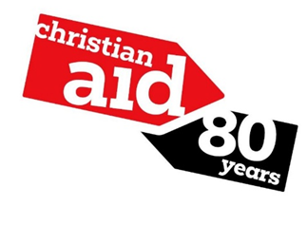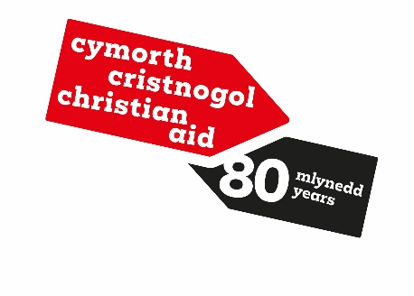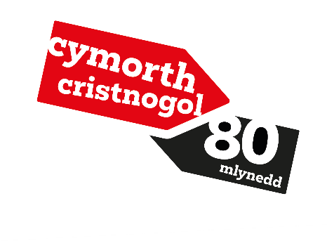

Please apply the most relevant logo in a top left corner.

Images

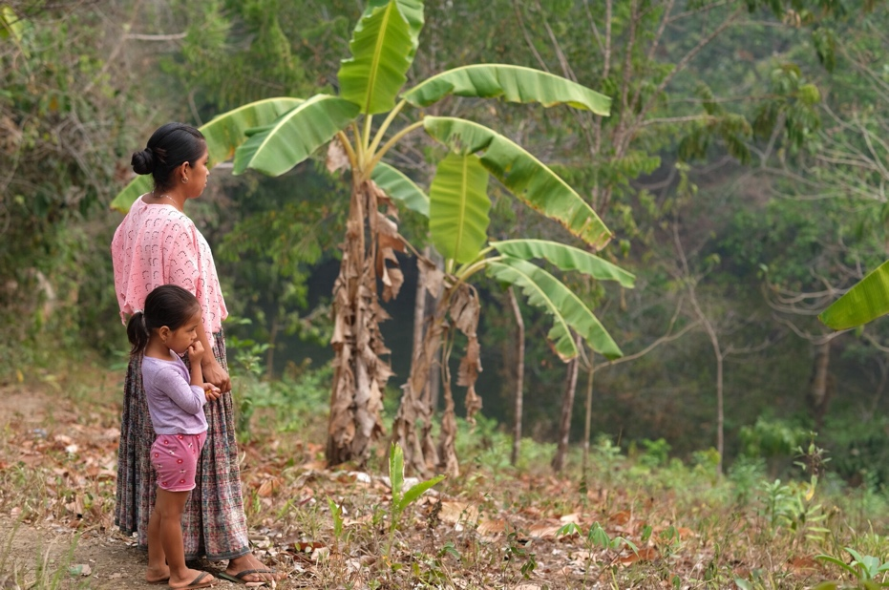

Caption: Amelia with her 4-year-old daughter, Yakelin, surveying the tragedy of their dying banana trees during an intense heatwave.
Credit: A.Sheppey/Christian Aid

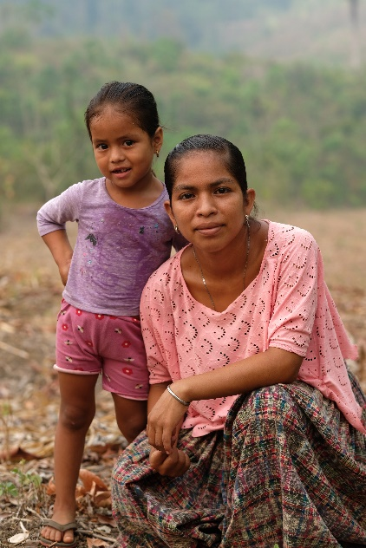 | 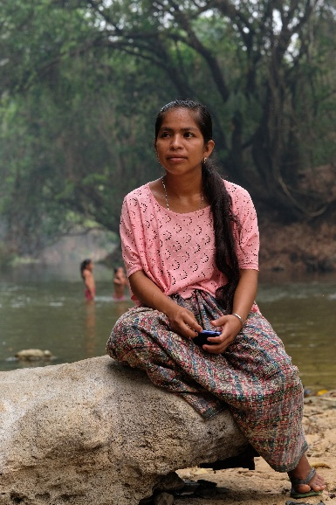
Caption: Amelia with her daughter, Yakelin.  Credit: A.Sheppey/Christian Aid | Caption: Amelia, by the river where the water level used to reach waist-height.  Credit: A.Sheppey/Christian Aid
A guide to using our template press releases

Thank you for supporting Christian Aid, and for sharing what you’re doing with your local press. Our template press releases are designed to give you a foundation for getting your message out to newspapers, radio and television in your community, and further afield.

Here’s the best way to use these press releases:

- Copy and paste the whole release into a new document so you have the original for a follow-up story (about how much you raised, for example).
- Fill in the parts in red (change the colour back to black and un-bold) – adding/deleting/changing quotes to your own words, as appropriate.
- Attach a photo that illustrates your story (one which has people in it preferably – with first and second names if there are fewer than five people).
- You can then send the release and photo/s out to the media yourself (the emails of news desks can be found on the relevant media’s website), or you can email Lisa Fagan at LFagan@christian-aid.org who will be happy to send it out for you to all relevant outlets, and organise any interviews that may be requested.

Template press release for general fundraising

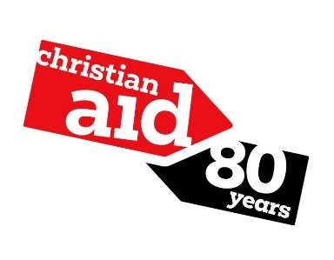
NEWS RELEASE
7 days to make a difference
[INSERT TOWN] fundraisers are gearing up for a major charity appeal to support communities living in poverty across the world.
[INSERT NAME OF GROUP eg Newtownards Christian Aid Group] have organised [INSERT ACTIVITY eg a sponsored cycle, a coffee morning] as part of Christian Aid Week 2025.
Organiser/Christian Aid Group chairperson [DELETE/AMEND AS APPROPRIATE AND INSERT NAME eg Jane Smith] said: ‘Every year, during this appeal, people across Britain and Ireland have 7 days to make a difference and raise funds for Christian Aid Week. We hope people will get behind our fundraising and support their global neighbours. Together, we can put the unstoppable power of hope into action, because a brighter, fairer future is possible.
‘We’re taking part in Christian Aid Week by [INSERT WHAT, WHERE, DATE AND TIME] because [EXPLAIN WHY THIS IS IMPORTANT TO YOU.]’
Money raised will enable Christian Aid and their trusted partners to support communities to find practical and sustainable ways out of poverty on their own terms.
This year’s Christian Aid Week (11-17 May) is focusing on Christian Aid’s work in Guatemala, Central America, where the climate crisis is causing the seasons to intensify and shift erratically. As a result, farming communities have to battle devastating floods and intense heatwaves. Water sources are drying up and vital crops are failing, plunging farming families into hunger and poverty.
Amelia is a resourceful and determined 24-year-old farmer, and a mother of two, from the Alta Verapaz region. She said the situation is very worrying: ‘In the past three years, we’ve been experiencing high heat and a lack of rain. One of the biggest issues is the lack of water … my plantations have been dying … and there is no food for my family.’
Despite the challenges families like Amelia’s are facing, the unstoppable power of hope drives people to look for ways to push back.
With training from Christian Aid’s partner, Congcoop, Amelia’s gaining the skills and knowledge to cultivate native seeds that are better suited to the changing climate. She’s planning planting schedules that will deliver multiple harvests throughout the year, making her own organic fertiliser, and constructing rainwater collection systems.
Amelia’s also a leader in her community, sharing her knowledge with other households, so that one day, no family will worry about their children going without food.
To find out more about projects like this, visit caid.ie
To get involved with Christian Aid Week, visit caweek.ie
ENDS

Notes to editors:
To find out more about Christian Aid Week, the events and challenges taking place, and the people whose stories we’re sharing, visit caweek.ie
For more information, contact Lisa Fagan, Communications Officer: LFagan@christian-aid.org

Christian Aid’s 80th anniversary:
For 80 years, Christian Aid has been fighting poverty and injustice. We've partnered with communities and organisations across the world to support people of every faith and none. We know that eradicating poverty can seem like an impossible task. But over these 80 years, we’ve harnessed something formidable. Something so full of love that it can’t be silenced. We call it the unstoppable power of hope. Hope has compelled us to stand up for communities in crisis and support people living in poverty. And right now, we need it more than ever. As tragic events unfold across the world, from Gaza to Ukraine and South Sudan, we need your support to offer hope to communities in crisis. Together we’re unstoppable. Find out more at caid.ie

